NAD Previews M66 BluOS Streaming DAC-Preamplifier at Shanghai Audio Show
  - Show attendees will have the chance to demo the flagship component, set to ship in November 2023
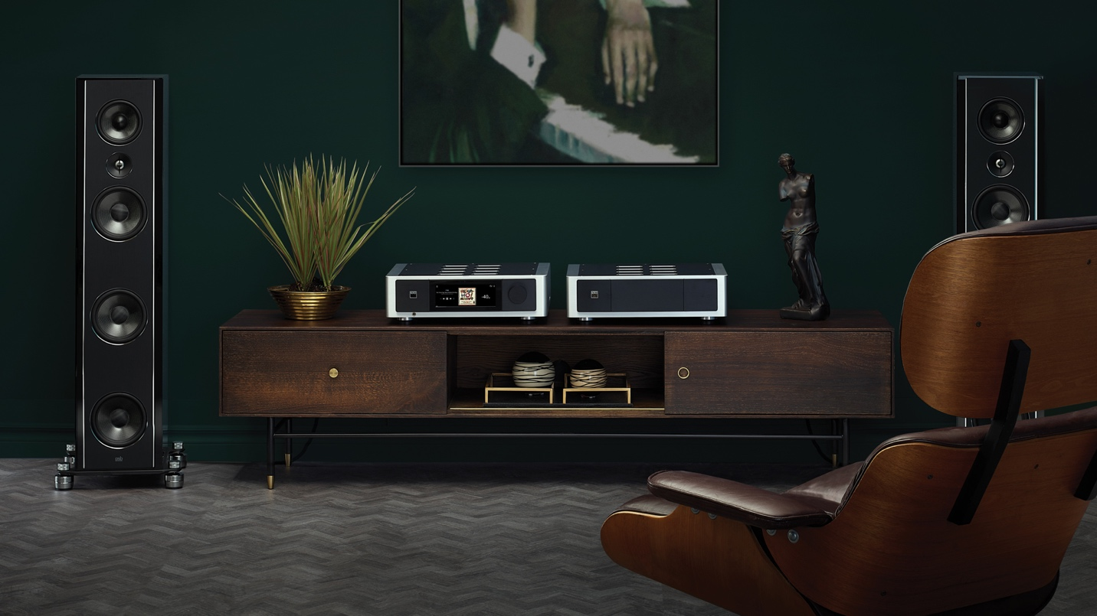
M66 BluOS Streaming DAC-Preamplifier in lifestyle setting
OctOBER 13, 2023, Shanghai Audio Show, Shanghai, China – NAD Electronics, the highly regarded manufacturer of high-performance audio-video components, kicks off a month-long series of activities celebrating the release of the Masters M66 BluOS Streaming DAC Preamplifier’s at the Shanghai Audio Show in China, ahead of shipments arriving to global retailers in the second half of November 2023. All Shanghai Audio Show attendees will have the exclusive opportunity to preview and demo the full features of the M66 –a high-end preamp so advanced, it represents an entirely new category of hi-fi separates. The M66 will be available for purchase in November and will be available at participating NAD authorized retailers at a suggested retail price of US$5,499 / GBP£4,499 / EUR€5,999 / CDN$7,299.

The NAD Masters M66 is one of the most feature-rich and technologically advanced preamplifiers on the market today. Its exceptional circuitry design features separate digital and analogue signal paths that add functionality like distinct volume attenuation for analogue and digital signals, a true analogue bypass for the MM/MC phono stage, and an independent headphone amplifier. It also boasts four independent subwoofer outputs and includes licenses for Dirac Live Room Correction (full frequency) and Bass Control tools. The M66 also introduces a new proprietary technology, Dynamic Digital Headroom (DDH), that eliminates intersample clipping and relies on the widely lauded ESS Sabre DAC, ensuring only the cleanest signal is passed along for amplification. BluOS wireless hi-res multiroom streaming, is included, as are Apple AirPlay2, two-way AptX HD Bluetooth, and a host of other inputs and outputs.

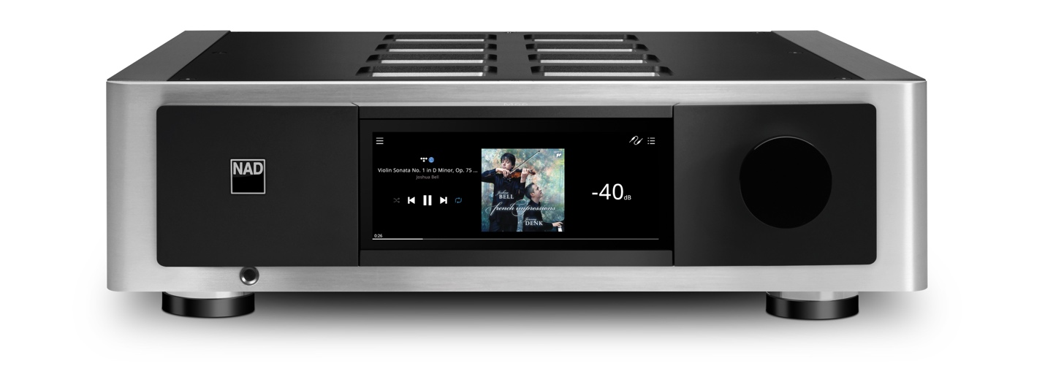
M66 front view

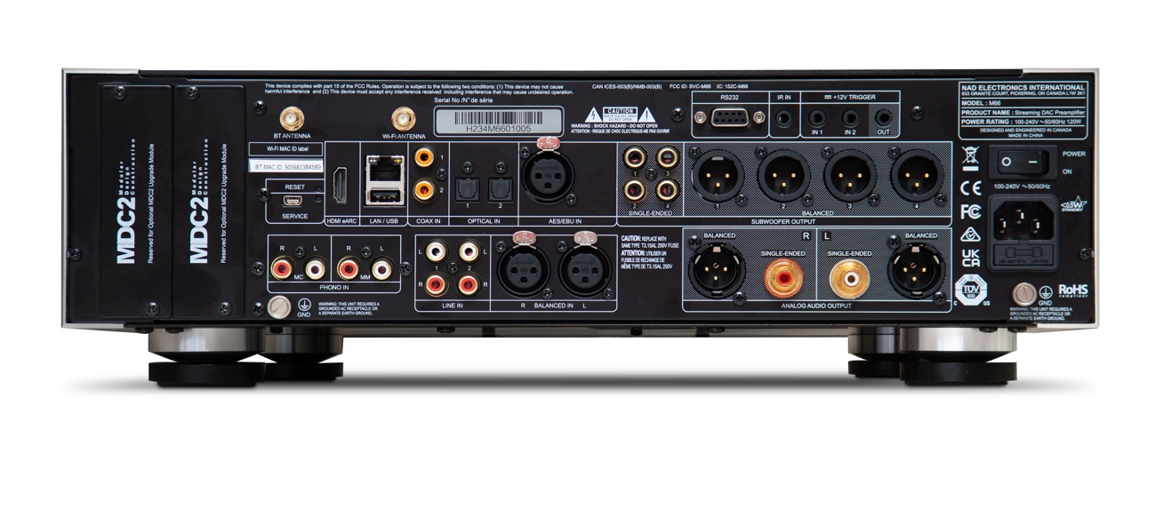
M66 rear view
"China has been one of NAD's fastest growing markets and we are very excited to be able to have Chinese audiences be among the first to see the full extent of what the M66 is capable of," explains Cas Oostvogel, NAD Product Manager, of the brand's decision to use the Shanghai Audio Show to open the product's official launch activities. "We chose the Shanghai Audio Show over those in Melbourne, Paris, and other locations because of the market's embrace of the brand."

Features & Details*

- Ethernet and Wi-Fi networking
- BluOS network streamer provides access to over 20 streaming services, including several that deliver lossless and high-resolution audio
- Flagship ESS Sabre DAC and ADC chips
- Innovative Dynamic Digital Headroom (DDH) circuit eliminates digital intersample peak clipping distortion
- Full MQA hardware decoding and rendering
- Analogue Bypass Mode available
- Separate signal paths for digital and analogue sources; separate power supplies for digital and analogue sections
- Supports popular music casting protocols like Apple AirPlay 2, Spotify Connect and Tidal Connect
- Seamless integration with smarthome control systems such as Crestron, Control4, ELAN, RTI, URC, and others
- Four independent unbalanced RCA and balanced XLR subwoofer outputs
- Full bandwidth version of Dirac Live Room Correction and Dirac Live Bass Control licenses included
- Ultra-quiet MM/MC phono stage with precise RIAA equalization, high overload margins, and infrasonic filter
- HDMI port with eARC support
- Two optical and two coaxial S/PDIF inputs, one AES/EBU balanced digital input, two pairs of RCA line-level analogue inputs, one pair of XLR balanced inputs
- Option to switch off WiFi and Bluetooth to minimize RF interference
- Dedicated headphone amplifier with low output impedance and very high output voltage capability
- Ultra-precise resistor-ladder digital volume control
- 7″ front-panel touchscreen
- Elegant aluminium casework
- Two MDC2 expansion slots for adding future capabilities
- IR remote
*all features and details listed are preliminary

About NAD Electronics
Founded in 1972 and now sold in over 80 countries, NAD Electronics is renowned for its
award-winning line of high-quality components for audio, home theatre and custom
installation applications. Since the beginning, NAD’s commitment to four core values –
innovation, innovation, simplicity, performance, and value – have earned it a cult-like
following that catapulted it to becoming a household name amongst audiophiles and
music lovers alike. To this day, the brand continues to design and manufacture some of
the most acclaimed and affordable hi-fi components that include modern features and
technologies meant to appeal to a new generation of audiophiles.

contacts

US Media Relations
Jeff Touzeau (OLEX Communications – US/Canada)
+1 914-602-2913
jeff@olexcommunications.us

UK Media Relations
Steve Dalton (OLEX Communications – UK)
+44 (0) 7748-117-864
steve@olexcommunications.co.uk

Links
Website: https://nadelectronics.com
Media Toolkit: https://brandlibrary.lenbrook.com/galleries/5459c256-32b5-49ee-9a2b-c1173d5ff662_acdab116-f505-49c3-899d-739ed5310796-ExternalUser
Facebook: https://www.facebook.com/nadelectronics
Twitter: https://twitter.com/NADElectronics
Instagram: https://www.instagram.com/nadelectronics/

# # #

